Michael Dang – 16257750

COMP-SCI 5565

Stat Learning: Features and Mode Selection Lab

11/17/2023

1. Part A.

Code

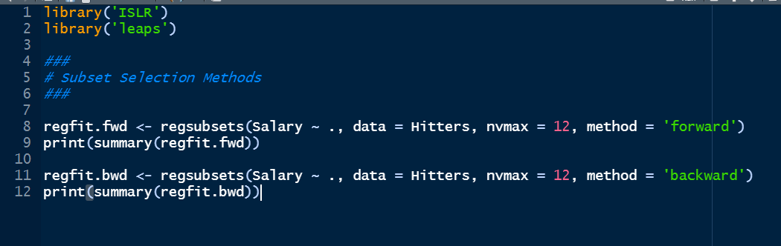

Output

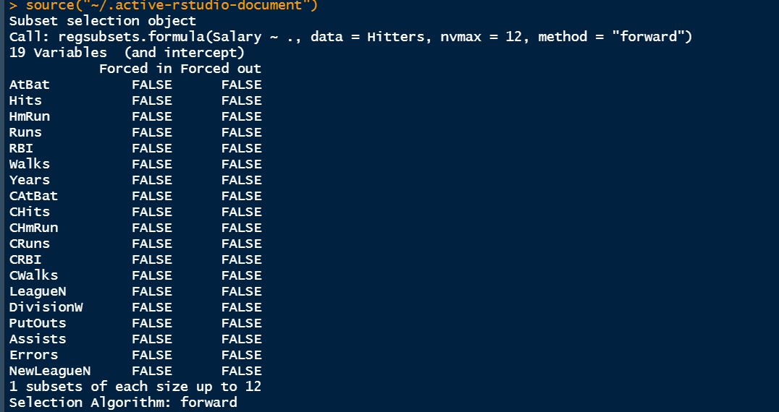

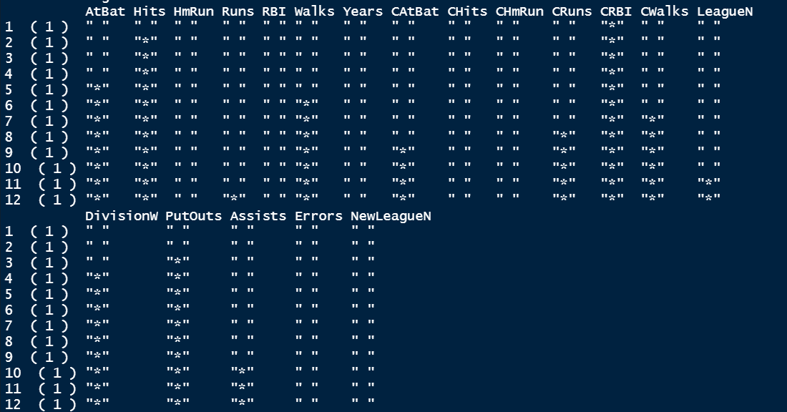

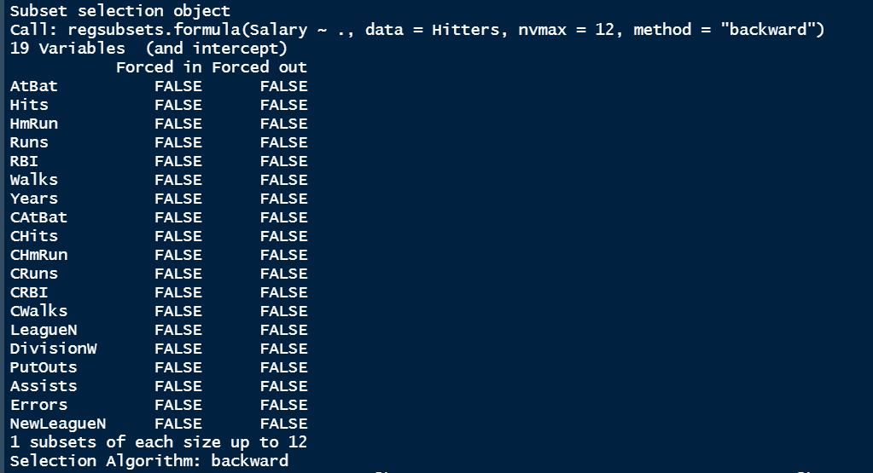

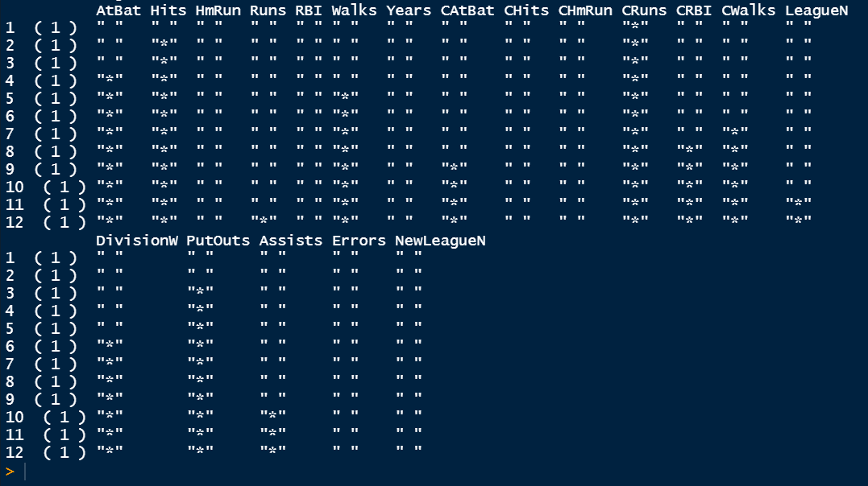

* The forward selection and the backward selection return the same result. My observation is that the number of features reduced from 19 to 12.

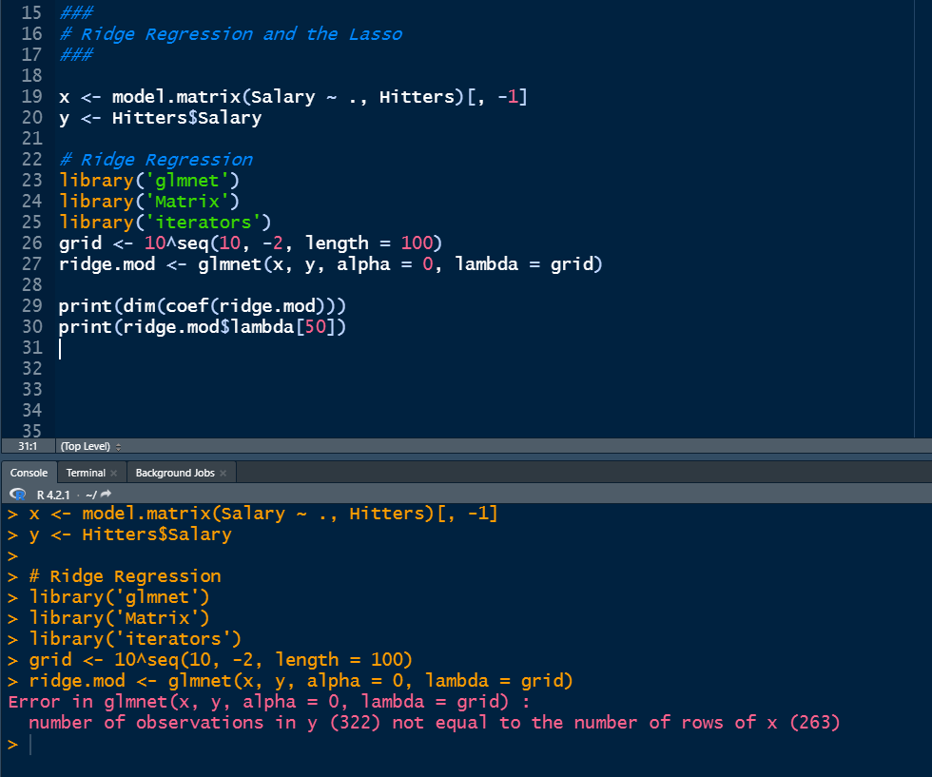

The code returns an error for model.matrix() function since it drop the N/A value.

III.

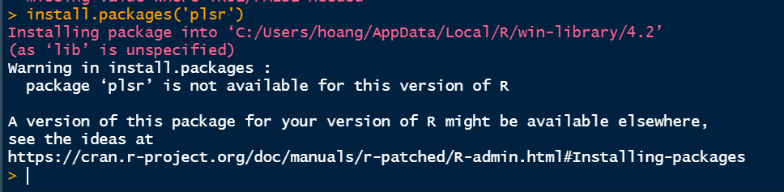

I can’t install package ‘plsr’, I tried to link the repository from GitHub but it doesn’t work.

1. Part B.

I.

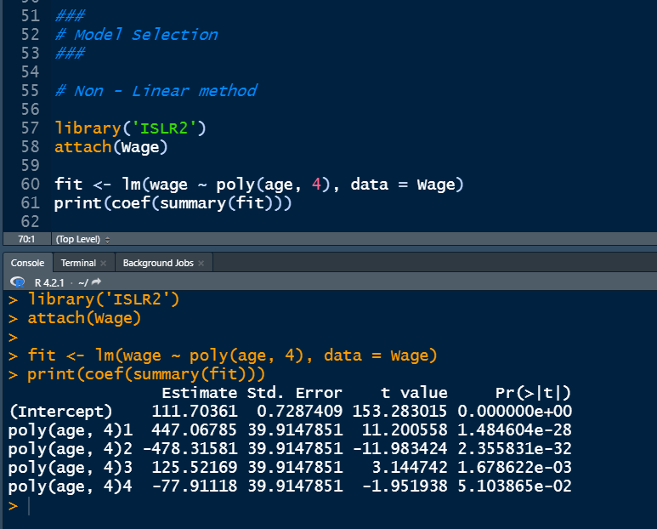

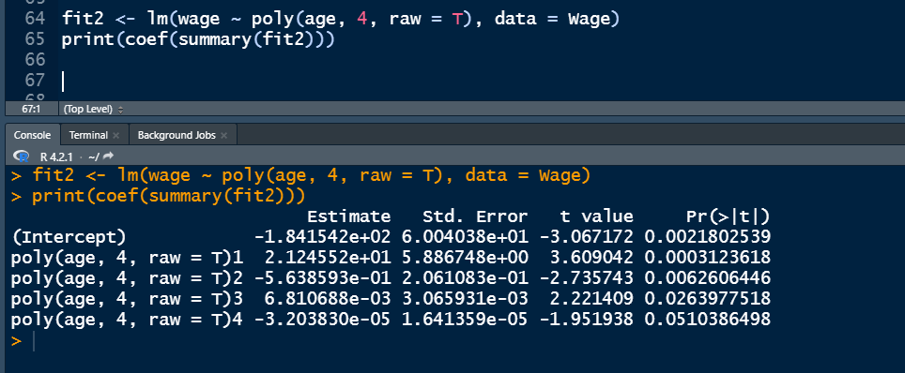

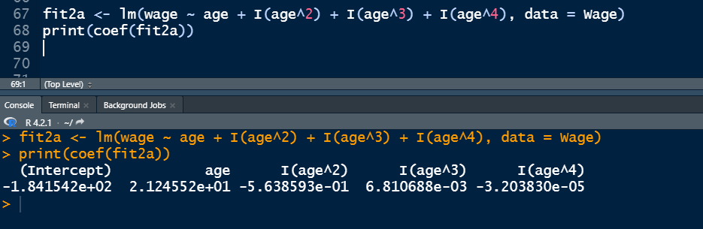

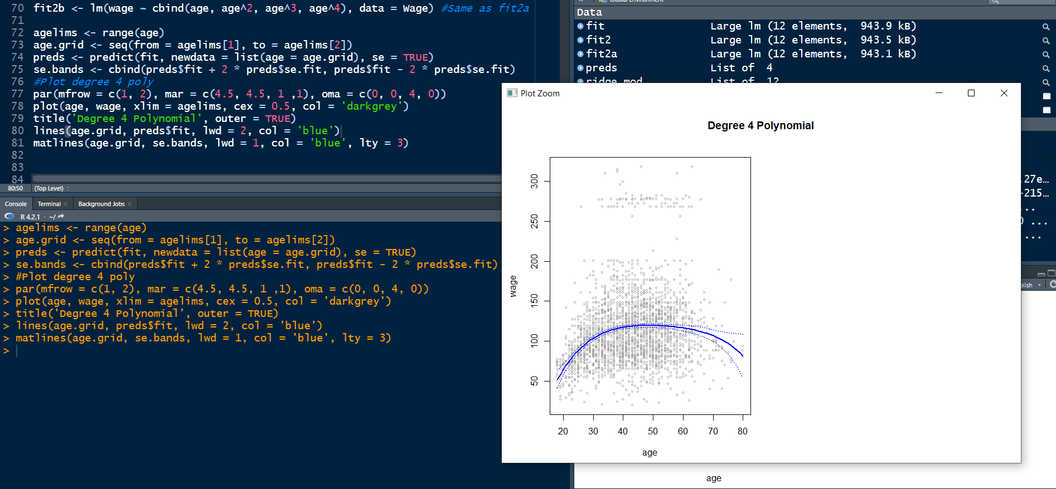

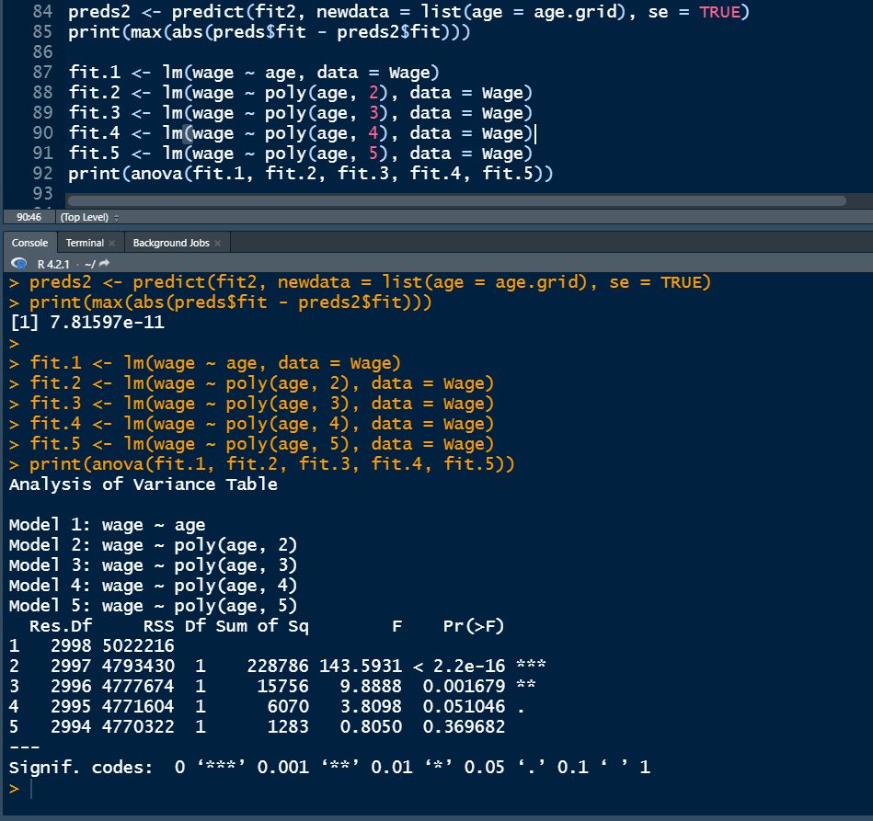

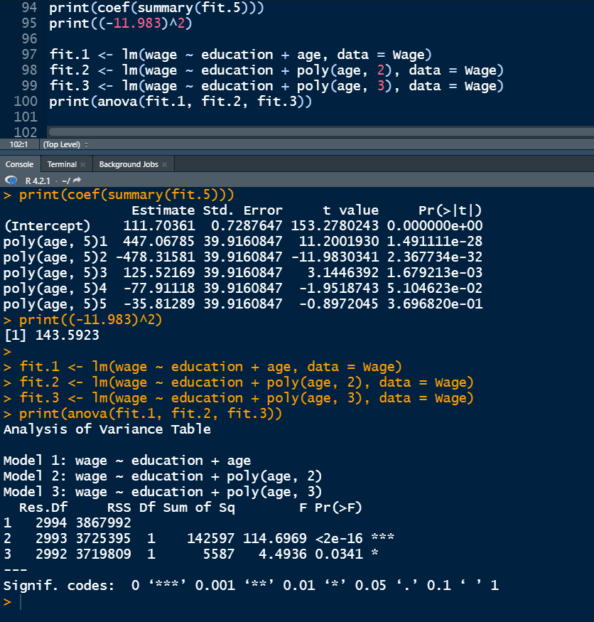

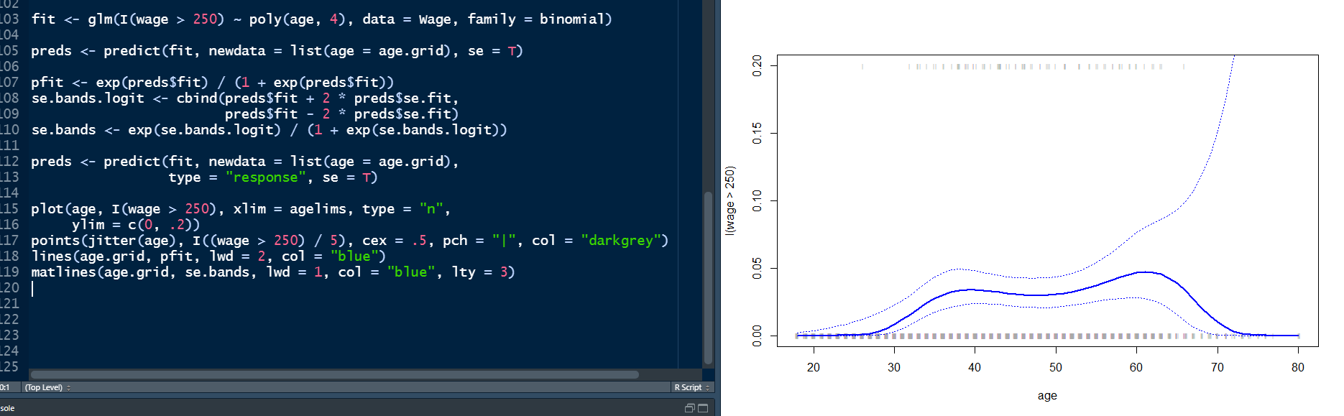

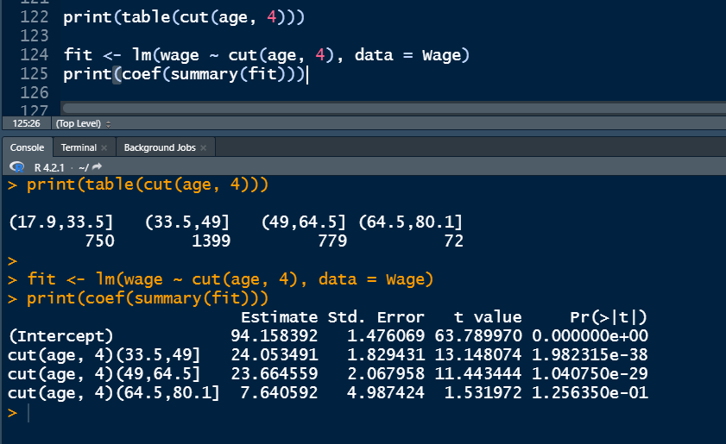

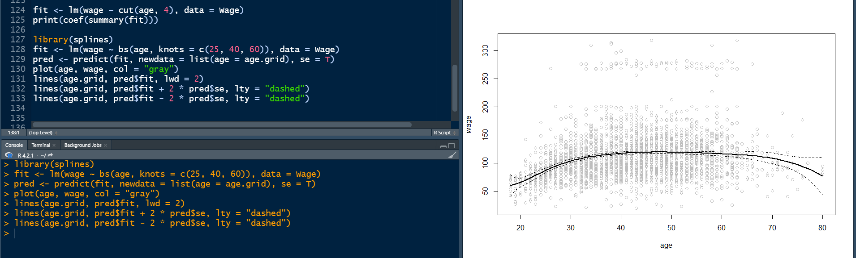

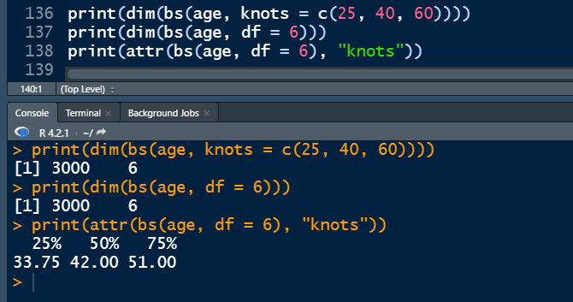

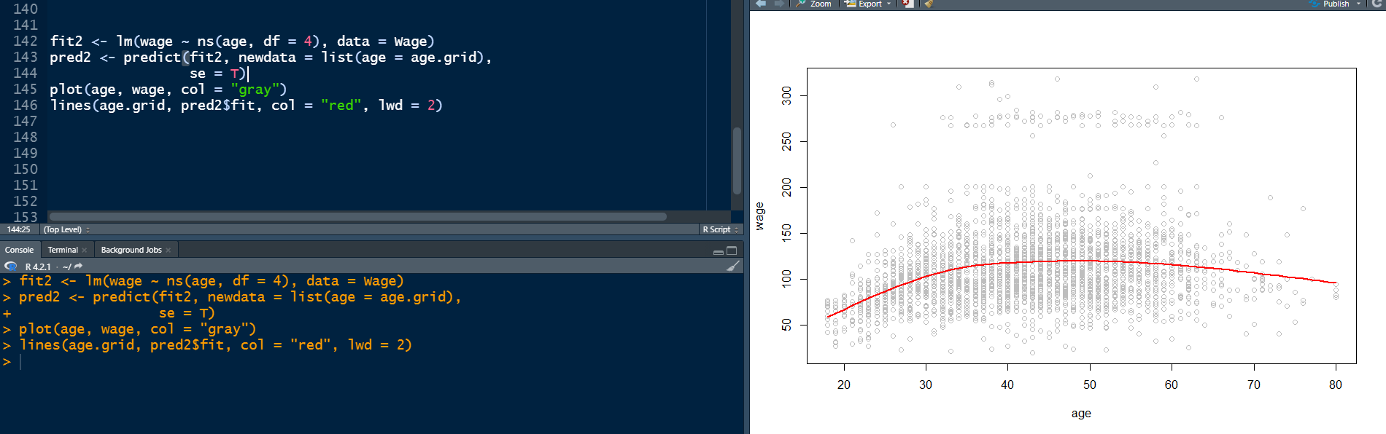

16 degrees of freedom

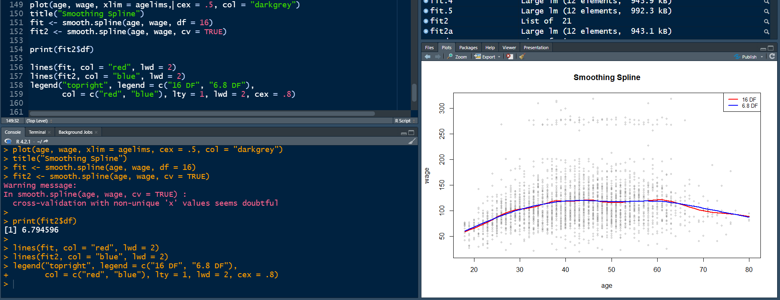

9 degrees of freedom

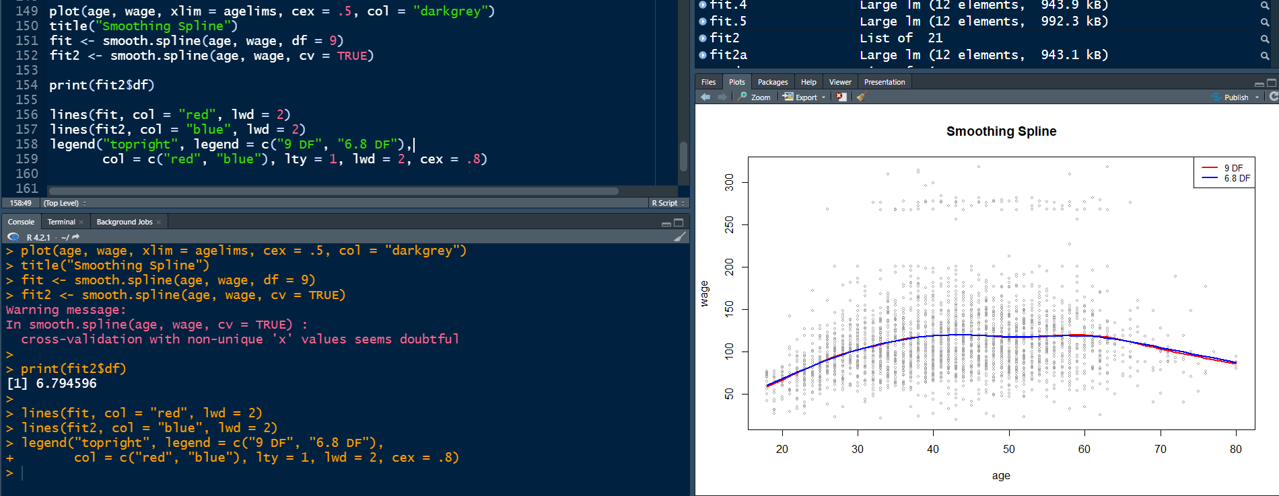

22 degrees of freedom

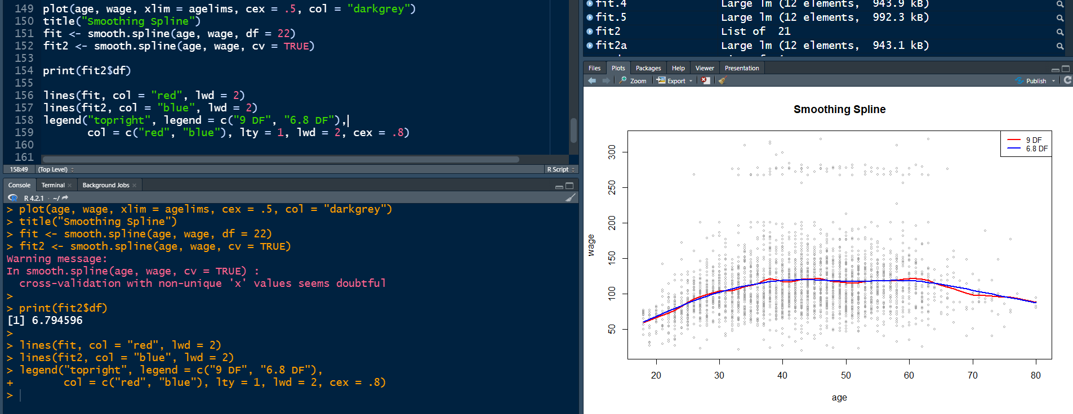

The 9 degrees of freedom fit well with the data meanwhile the 16 and 22 degrees of freedom happen to have a overfitting for the data.